some mathematics of the cantilever pendulum -
Alan Emmerson
After writing Pendulums Revisited, I thought I ought to make a more determined effort to run out the equations for the cantilever spring suspension. I say “run out” rather than “solve”, because the equations are really just slightly complicated applications of standard engineering methods that were devised about 200 years ago. I had studied the work of Kenneth James, in May 1998, but, because his presentation was so different from that usual in engineering, I did not understand it well enough to be happy with his result. My motives were to expose the mathematical basis of the vibrations superimposed on the principal oscillation of the pendulum, to comment on the “centre of swing” concept, and to explain the basis of the Fedchenko suspension.
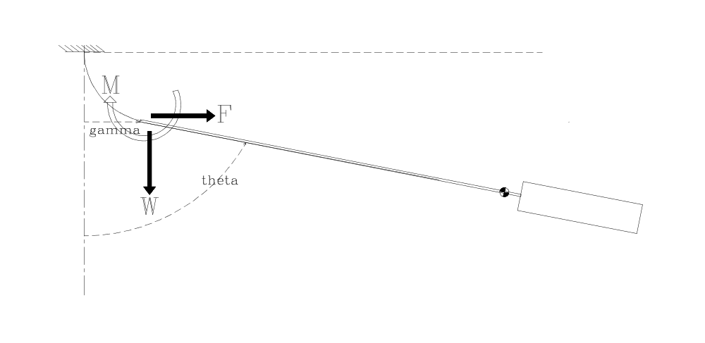
Figure 1
Derivation
The first part of the problem is nothing more than examining a tip loaded cantilever to which an axial load is applied. Consider a suspension-spring to which, as shown in Figure 1, a vertical force W, a moment M, and lateral force F are applied at the point of attachment of the suspension-spring to the pendulum-rod. They rotate that point through an angle q and displace it laterally a distance g. Those displacements apply to both the end of the spring and to the top of the pendulum rod.
Setting:
l as the length of the spring
E as Young’s modulus for the spring material (but see further remarks), and
I as the second moment of area (bending “moment of inertia”)of the spring; and
adopting the usual notation and sign conventions we have:
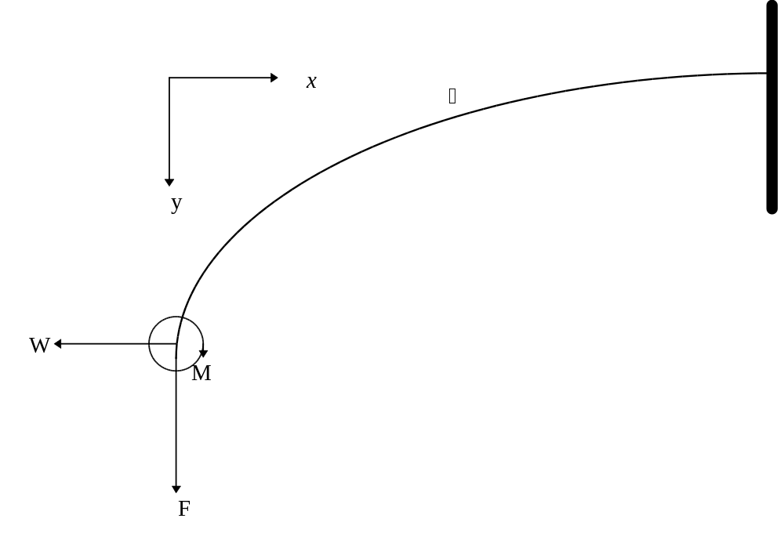
Figure 2
Equation of elastic curve is 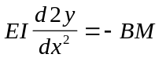
This is “engineers’ theory of bending” and applies only for small deflections where 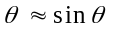. The theory is the work of Bernoulli J. 1705, Bernoulli D.1742, Euler 1744 and Coulomb 1776. We also assume that the change of bending moment due to tensile extension of the spring is negligible and that the lateral force F does not contribute significantly to direct tension in the spring. These are fundamental assumptions and approximations that have stood the test of time for engineers but may yet prove not to be sufficiently precise for horology. We can be confident though that the general performance of our pendulum suspension spring will be satisfactorily represented by this theory.
Thus 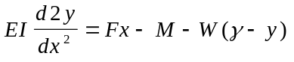

call 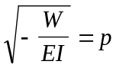
then 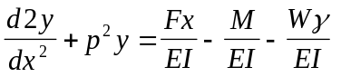
This is a differential equation of a class for which the general solution is well known.
That solution is:

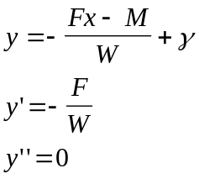
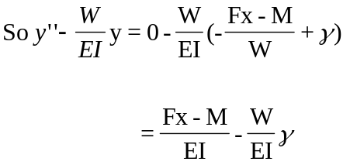
and PI is valid
We choose particular integral 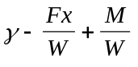
Thus 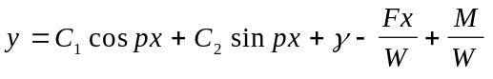 
The constants C can be obtained from the boundary conditions:
When 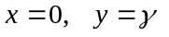
 gives 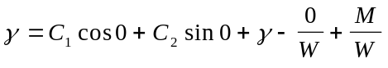

Thus 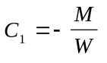
When 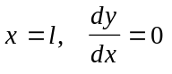
ie 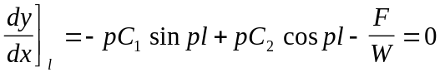
thus 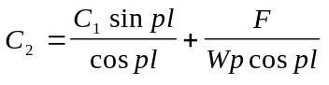
but 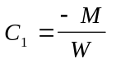
Thus 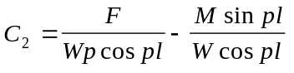
Substituting in  we obtain:
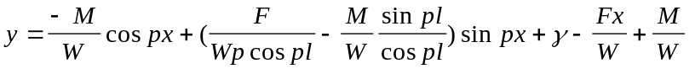
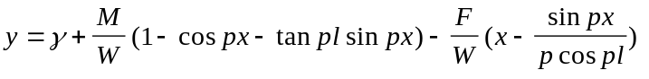 ‚.
Check: At x=0, y=γ
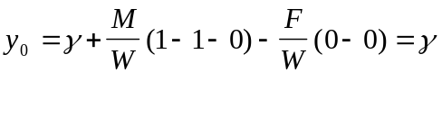 ok
Tip Displacement
Equation ‚ permits us to express the tip deflection γ in terms of the applied forces and moments. We know that when x=l, y=0. Substituting in ‚ gives:
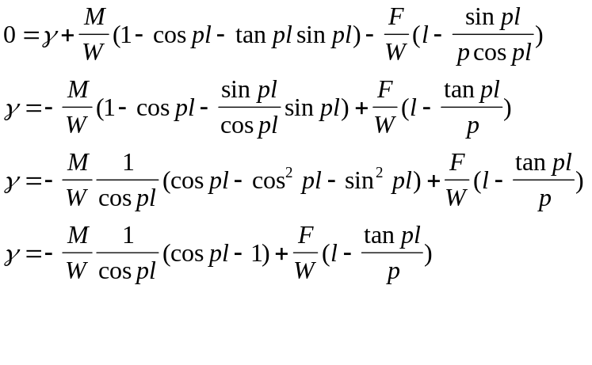
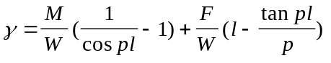 ƒ.
Now we have predetermined that at the tip of the cantilever, where x = 0, the rotation or slope will be q. Where q is positive when measured clockwise from the x axis. Equation  shows that at x=0
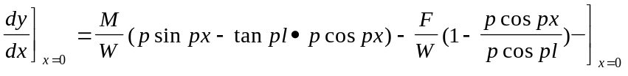
But 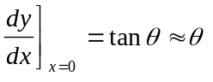
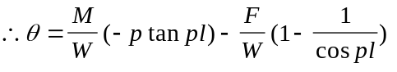
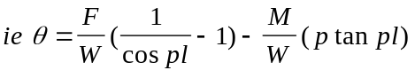 „.
Equations ‚, ƒ and „, give us the shape of the suspension spring and the displacement of its tip in terms of the applied loads F,W, and M. But with a moving pendulum, F and M will generally be unknown and W will only be known approximately. So, it will serve us to recast these equations in terms of the observable variables γ and θ.
Begin by introducing dummy variables A, B and C
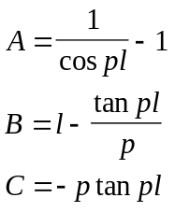
Eqn 3 is 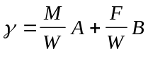
Eqn 4 is 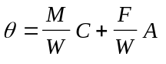
Solving these two simultaneous equations gives :
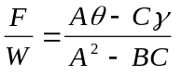 …
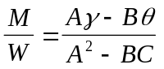 †
The force F and the moment M are the force and the moment which arise when a pendulum rod is rotated through an angle θ and displaced laterally a distance γ while being pulled down by a force W. That of course is just what happens firstly when the pendulum is moved by hand to start it, and then when it is subsequently acted upon by gravity.
It is tempting to conclude from … and † that 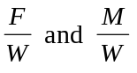are linear functions of γ and θ and that we have a simple spring; but that is not correct as A,B and C are complex functions of W which in turn is a complicated function of θ and time.
Now is the time to expand part of that complexity.
The dummy variables can be replaced by their values. Thus:
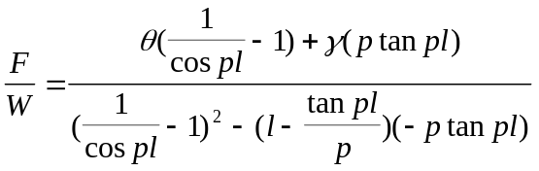
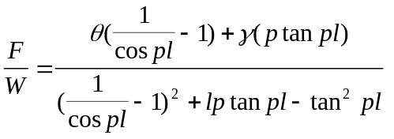 ‡.
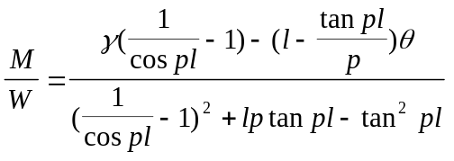 ˆ.
Now 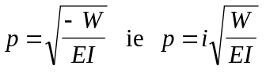 say 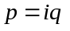,
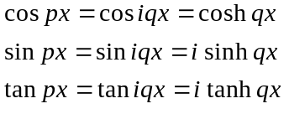
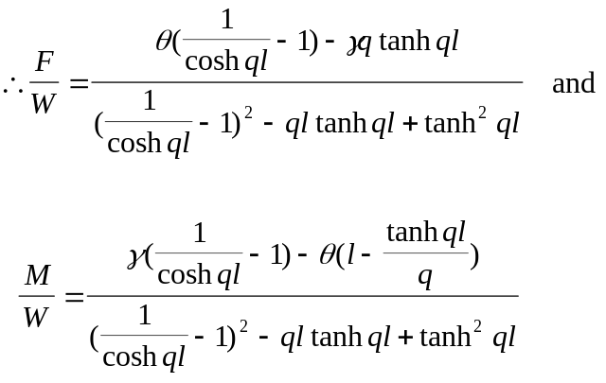 ‰.
And from ‚
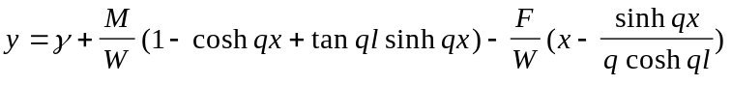 10.
This is the equation of the elastic curve of a suspension spring with the tip deflected laterally a distance γ and rotated through an angle θ with a vertically downward load of W applied at the tip.
Numerical Example
If we take a pendulum with a suspension-spring ½ inch long by ½ inch wide by five thou thick,
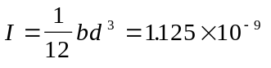in⁴
Wide beams, such as thin metallic strips, are more rigid than simple engineer’s theory of bending suggests. It is usual to account for this effect by using E/(1-e²) where e is Poisson’s ratio, instead of the value of E tabulated for the material. If the spring is steel 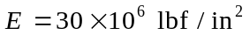 and e = 0.27 . Thus we use 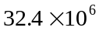 for E, and the bending stiffness of the spring is EI = 0.0364.
If the pendulum exerts a force W equal to 15lbf, then 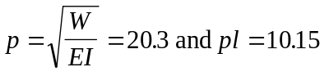
If our spring is deflected so that q = -3° and g = 0.025in then substituting in equations 4 and 5 gives M = 0..00183inlbf and F = 0.82266lbf. These are the moment and the force which a typical pendulum exerts on a conventional suspension spring at the end of the swing. A great deal of the apparently high stiffness is caused by the force W - say approximately the weight of the pendulum. This force reduces the bending moment and one must apply correspondingly larger F and M to achieve any specified deflection.
Now W is not actually constant. The value of W, and the relationship between γ and θ , are actually determined by the dynamics of the pendulum’s swing. We do not know this relationship. The relevant differential equations have defied man for many years.
However we can illustrate the sort of thing which will happen. Firstly, we can use a value for W that takes into account, approximately, the variation in W as the pendulum swings. Appendix A sets out the standard derivation of the forces at the top of the theoretical compound pendulum. For the purposes of illustrating the behaviour of the spring we can use the vertical force P_{c} to approximate W.
Note in passing that the horizontal force at the top of the theoretical compound pendulum in Appendix A is very much the same size as F calculated above.
Secondly, we need to deal with the unknown relationship between γ and θ . The spring can adopt one of two sorts of shape. The first shape has a reflex bend, that is, there is a point of inflexion near the middle of the spring. The second, more simple, shape does not have a reflex bend. A simple sketch will show that if the absolute magnitude of is less than 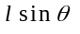 then there will not be a reflex bend and vice versa. We can see what shapes would be produced if the pendulum swung so that 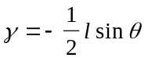 or so that 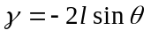 .
Figures 3 and 4 show the shape the spring can adopt as the pendulum swings from 0 to 3°
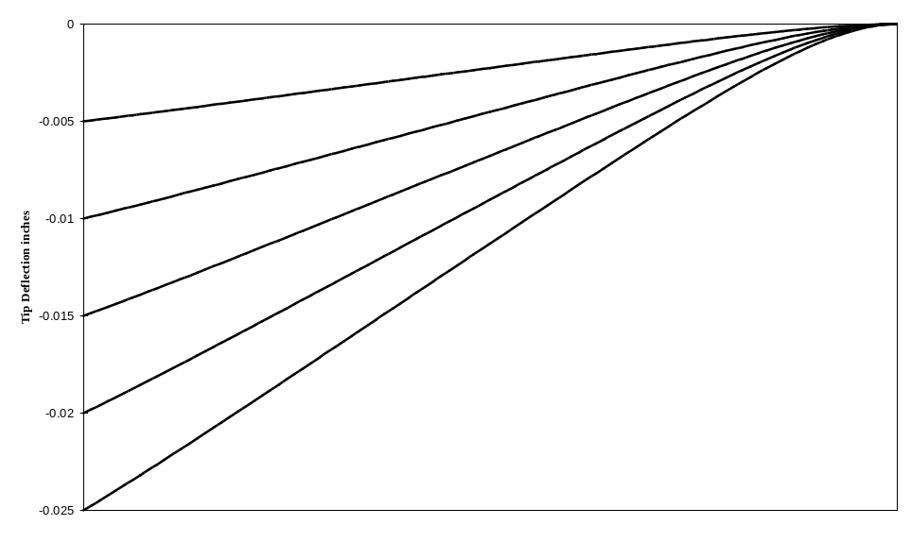
Figure 3 Simple Bending
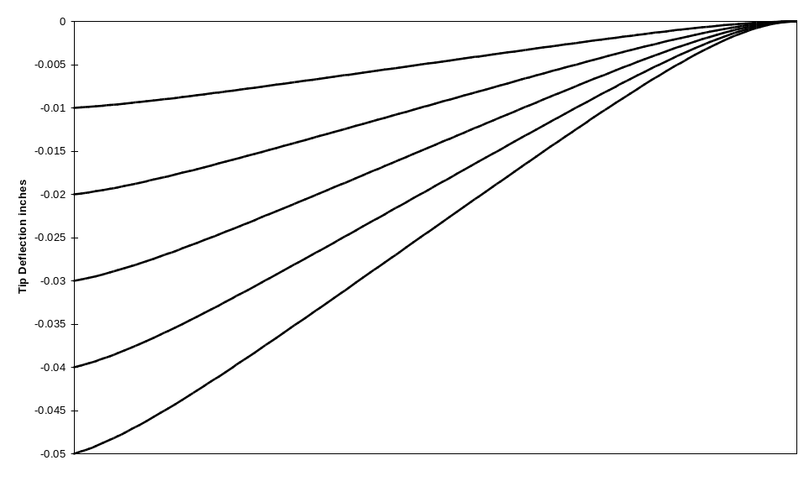
Figure 4 Reflex Bending

Equation 2 also leads us to an expression for the projected length of the beam once it has been bent, because in the engineers’ theory of bending, the apparent shortening of the beam is given by:
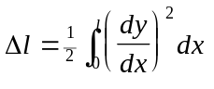
Now while we have justifiably ignored the effect on bending moment caused by the axial stretching of the spring under tensile load, we cannot ignore the effect in comparison with Δl
We can say 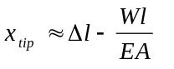 where A is the cross sectional area of the spring
That will give an expression for the vertical position, x coordinate, of the junction of the rod and the suspension-spring - albeit a rather messy expression.
I do not propose to evaluate 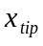 in this paper. Suffice to say it is very small.
Forces and Moments on the Rod
F, M and W are the forces exerted on the spring by the rod. If we wish to consider the motion of the rod we need to deal with the forces and moments exerted on the rod. These will be equal and opposite to F, M and W. To avoid confusion we introduce the forces R and P and the moment Q as shown in the following diagram.
(Diagram to show R vertically up. P horizontally to left Q anticlock wise)
Taking clockwise moments about the centre of the pendulum’s mass, we have.
Thus the moment tending to restore the angular displacement to zero is :
My reason for setting down this equation is to draw attention to what happens when the spring changes from bending simply to bending reflexively. With reflex bending P changes sign. There is a corresponding change in the restoring moment. I think the change in restoring moment acts so as to change the pendulum motion so that, after a short time the reflex bending no longer occurs. I think also that if reflex bending could be made to happen continuously it could be a contribution to isochronism .This has some significance in considering Fedchenko’s suspension described in Appendix B.
Instantaneous Centre of Motion
In the past, considerable attention has been given to determining the “centre of swing” of the cantilever-spring-pendulum. I am not sure why. That is, I am not completely sure what the authors intended to do with the answer; and I am even less sure that their purposes could have been validly served by the answers made possible by the methods used.
Nevertheless, the instantaneous centre of motion is a valid concept and one commonly used in the analysis of mechanisms. At any particular instant, the total motion of a rigid body is equivalent to a rotation of the body as a whole about some point in space. Although it is possible to calculate the acceleration and velocity of a point in a mechanism analytically in some simple cases, more generally it is impractical and graphical methods are used. The instantaneous centre method lends itself to a graphical approach.
If A and B are two points in a rigid body, then the instantaneous centre is located at the intersection of lines drawn through A and B respectively perpendicular to the velocity vectors of A and B. Figure 5 illustrates the construction. The instantaneous centre is not a fixed point. Most usually it moves continuously.
The utility of the instantaneous centre comes from the fact that the velocity of any point on the body is proportional to its distance from the instantaneous centre and has a direction perpendicular to the line joining the point to the instantaneous centre. (The constant of proportionality is the angular velocity of the body.) This means, for example, that knowing the instantaneous centre of a pendulum rod, and its angular velocity, we could determine the velocity ( speed and direction) and thence the position in space of the point on a pendulum rod where the crutch bears. The point being that it is the position of the crutch which actually “tells” the time.
There is a useful connection between the velocities of points A and B. The velocity of B is equal to the velocity of A plus the velocity of B relative to A
ie 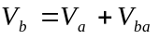
We must also recognise that the body’s being rigid means A and B must not move further apart nor closer together. That means the component of the velocity of A along the line joining AB must always be the same as the component of the velocity of B along the same line. That is the same as saying the velocity of B relative to A must always be perpendicular to AB.
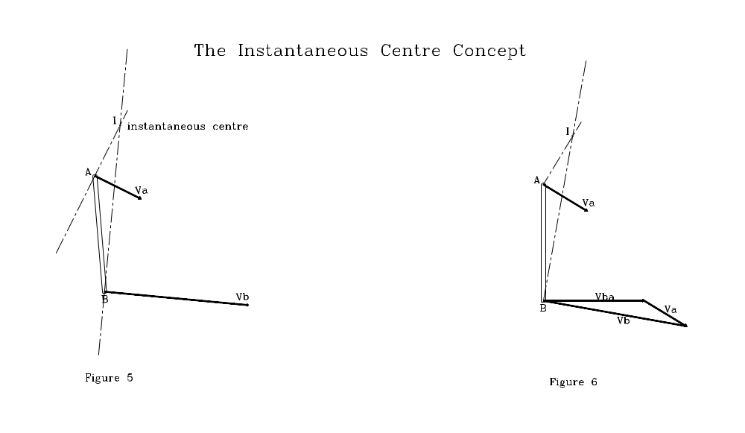
A generalised presentation of the vector addition and the subsequent determination of the instantaneous centre is shown in Figure 6. To actually draw this diagram we need to know two of the three variables 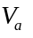, 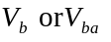.
Suppose we allow the rigid body containing A and B to represent our pendulum, A at the tip of the suspension-spring and B at the centre of mass.
From Fig 6 you will see that the smaller is and the closer its direction is to being perpendicular to the rod, the nearer is the instantaneous centre to the extended centre line of the rod. Thus if the tip of the suspension-spring always moved perpendicular to the local surface of the spring the instantaneous centre would always lie on the extended centre line of the rod. If the spring behaved in such a way, the curves for constant θ in Figure 4 would be straight lines. We can see that they are not straight lines and can conclude that the spring does not generally behave in that way, although it might be induced to do so in particular circumstances. So, the instantaneous centre of motion does not generally lie on the extended centre line of the rod. The sort of thing we might expect in the simplest case is something like Figure 7.
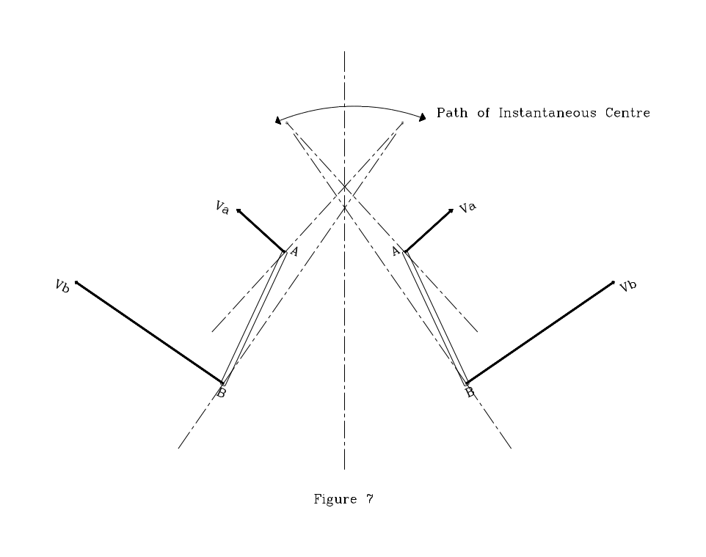
We have said that 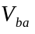 is perpendicular to AB. Because of our definition of θ, the angular velocity of the rod is 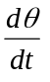 and therefore 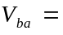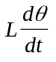 where L is the distance between A and B.
For purpose of illustration it might be satisfactory to make some assumption about 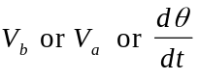, so that we could point to a “centre of swing”. We could say for example that the vertical movement of the top of the rod is negligibly small. That point would then move in a horizontal straight line and the instantaneous centre would always be vertically above the top of the rod. But in reality such illustrations would be nothing more than that - each an illustration of one feasible situation and not a true general statement about the position of the instantaneous centre.
To find the instantaneous centre of the pendulum rod we might now proceed to differentiate 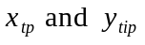 with respect to time so as to obtain , finding on the way from the dynamics. The relevant equations are equations 7 and 8. My wife Gay, who painstakingly checked all my algebra, expanded equation 7 so that we could see what we have to differentiate with respect to time - remembering that this would give just the vertical component of the velocity of the top of the rod. The resulting equation 9 is:
The prospect is more than daunting. Mathematicians say “A problem worthy of attack, Proves its worth by fighting back.” I’m not sure the converse is true.
Dynamics
The real question for time-keeping is how does the displacement of the crutch, or the gathering pallet, vary with time. This is the same as asking how does the position of a particular point on the rod vary with time. That is quite a different proposition from calculating the period of a harmonic motion.
Like any other rigid body, the motion of the pendulum can be treated as a rotation about its centre of mass together with a translational motion of the centre of mass.
Before we can write down the differential equations for the motion of the pendulum we need to know the position of the instantaneous centre. The reason is that we need a value for the force W. This force is not just the weight of the pendulum, because W, in conjunction with F, provides the centripetal force which causes the pendulum bob to move along a more or less circular path. Now although the centripetal acceleration is small, we are not entitled to ignore it. After all, the equation of motion for the simple pendulum is derived entirely from the expression for centripetal force. To evaluate the centripetal force we need to know the distance from the centre of mass to the instantaneous centre about which the pendulum is rotating so we need an expression for the position of the instantaneous centre.
If we were to try to use energy methods we face the same problem. To evaluate the translational kinetic energy of the pendulum we need to know the velocity of the centre of mass and that means we need to know the position of instantaneous centre of rotation. Even if we were to treat the vertical motion of the tip of the suspension spring as negligible, the subsequent algebraic complexity would be horrendous. I have examined the problem from many angles and I believe we are snookered by the algebraic complexity.
However, having made that examination, I can see that the motion is going to be described by two simultaneous differential equations with a peculiar characteristic. To illustrate, recall that the method of construction makes the end of the spring align with the pendulum rod and q coincides with the rotation of the rod about its centre of mass clockwise from the vertical. Call the horizontal displacement of the centre of mass Y and the distance from the top of the rod to the centre of mass L. Theta and Y will be functions of time.
The equations will be of the general form
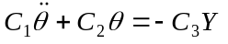 for the rotation, and
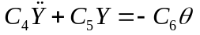 for the lateral translation.
The solution of each of these equations would represent the superposition of two harmonic oscillations. The two frequencies would be the natural frequency given by the left hand side of the equation and the forcing frequency given by the right hand side. The peculiar characteristic is that the rotational motion is forced by the translational motion, and the translational motion is forced by the rotational motion. If there is any damping present , and this is always so even though it is not shown in this analysis, the natural frequencies will be transient and will decay and the frequencies of oscillation will be that of the forcing functions. I think this means that in the long run the pendulum will swing so that the rotational and translational motions have the same frequency and the same phase. But if the pendulum is disturbed, by say an impulse, the transient frequencies will again appear.
Real engineering analysis can seldom be uncompromisingly precise.

© A.J. Emmerson, Canberra, 1998

Appendix A
REACtions at the pivot of the theoretical compound pendulum
(Diagram to show forces on rod at top are N along rod upwards T perpendicular to rod and to left.)
Because the upper end of the pendulum rod, point O, is fixed in space, we have, considering the angular and centripetal accelerations of the pendulum:
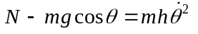 
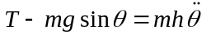 ‚
Angular momentum principle, with I_{o} as the mass moment of inertia about O, gives:
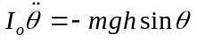 ƒ
Considering conservation of mechanical energy;
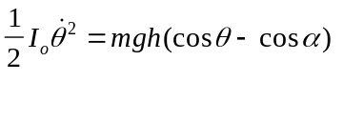 „
From  and „, recognising that 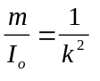 where k is the radius of gyration of the pendulum about O:
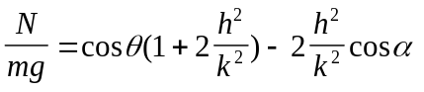 …

From ‚ and ƒ
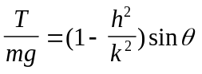 †
Translating these radial and transverse forces into vertical and horizontal forces we get:
Vertically upwards:
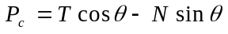
Horizontally to left:
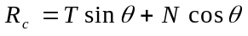
Where T and N are given by … and †.
The forces P_{c} and R_{c} are the forces which must be applied to a compound pendulum at the point about which it pivots if that point is to remain fixed in space.
They are not the forces at the top of the pendulum rod attached to a cantilever spring suspension, because the top of that pendulum is moving. However they should be about the same size as the forces on the cantilever pendulum because the top of the rod doesn’t move much.
Numerical Example
If we take a seconds pendulum of total weight 15lbf with h= 38in and amplitude 5°, we find that:
P_{c} = 0.765lbf and
R_{c} = 15.03lbf

Appendix B
Fedchenko’s Suspension
F.M. Fedchenko’s arrangement of the suspension is an assembly of three coplanar parallel springs disposed symmetrically about the centre line of the pendulum rod. The two outer springs are identical and their flexure length is much shorter than that of the middle spring. The sketch below is based on data from George Feinstein and on a general arrangement sketch by John W. Wood . The clamping method I have drawn is somewhat conjectural. The method was perhaps changed from one model to the next. But that is not material here.
The bending stiffness of the two outer springs can be represented by a single spring having twice the width. The forces and the moment acting on the suspension are shared by the springs according to the principle of strain compatibility. The equation for the elastic curves of these springs should show that there is a restoring torque which varies in a way that is close to that for isochronism, as Fedchenko demonstrated in practice.
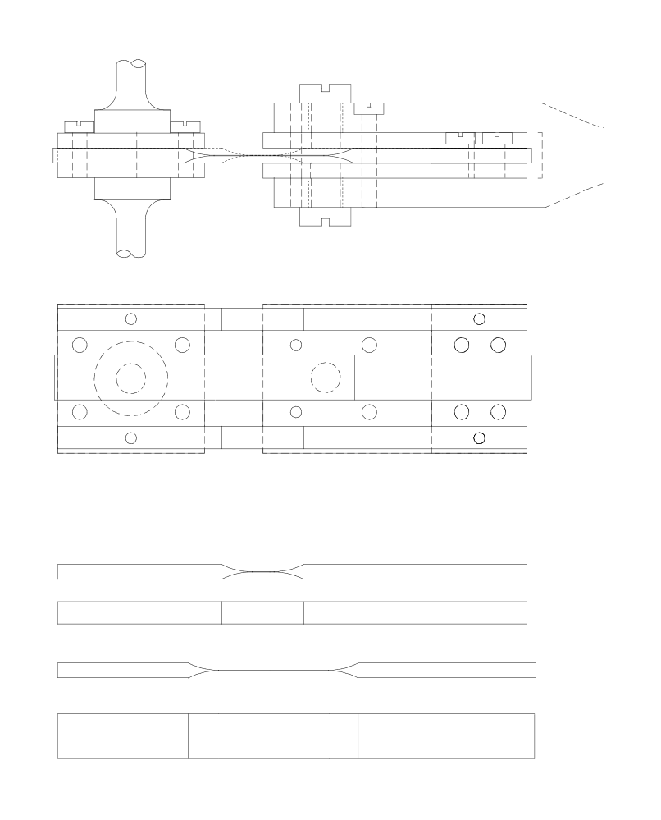
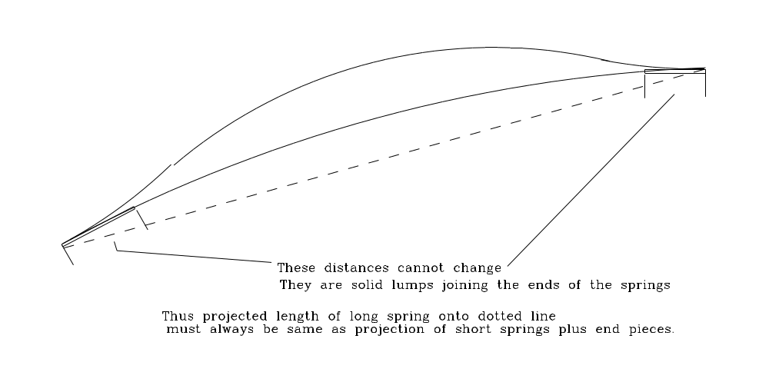

James.K Precision Pendulum Clocks - Circular Error and the Suspension Spring, Antiquarian Horology September 1974 pp868 et seq
When θ is 3° the difference between θ and sinθ is one part in two thousand.
This will also be useful when one comes to the Fedchenko suspension.
W is greater than the weight of the pendulum. It contributes part of the centripetal force which makes the bob swing in an arc.
An “acceleration centre” is also defined, using the fact that the acceleration of B relative to A is L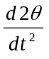 perpendicular to the rod and 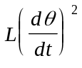 along the rod.
Feinstein G. AChF-3 Isochronous Suspension, Horological Science Newsletter, 1997-3 pp 13 et seq
Wood J.W. in Britten F.J. and Goode R. ed Britten’s Watch and Clock Makers Handbook Dictionary and Guide 16th Edition Bloomsbury Books, London 1978 p243

